Experiment 6

Aim: (i) Explore the GPG tool of linux to implement email security
(ii) SQL injection attack, Cross-Site Scripting attack simulation

Theory:

Introduction:
Email security is paramount in today's digital landscape, where cyber threats loom large. GNU Privacy Guard (GPG) is a powerful tool available on Linux platforms, providing encryption and digital signature capabilities. Leveraging GPG for email security involves understanding its functionalities, integration with email clients, and best practices for implementation.

1. Understanding GPG:
- GPG, an implementation of OpenPGP (Pretty Good Privacy), utilizes asymmetric encryption for securing communications.
- It employs public-key cryptography, where each user has a pair of keys: a public key for encryption and a private key for decryption.
- GPG facilitates secure email communication by encrypting messages using the recipient's public key, ensuring confidentiality.
- Digital signatures generated with private keys verify the authenticity and integrity of emails.

2. Integration with Email Clients:
- GPG integrates seamlessly with various Linux email clients such as Thunderbird, Evolution, and Mutt.
- Thunderbird, with the Enigmail extension, provides a user-friendly interface for GPG operations, including key management and encryption.
- Evolution, a comprehensive email client, offers native support for GPG, enabling users to sign and encrypt emails effortlessly.
- Mutt, a text-based email client favored by power users, can be configured to work with GPG for secure email exchange.

3. Key Management:
- Central to GPG's functionality is effective key management, ensuring the security and integrity of cryptographic keys.
- Users generate key pairs using GPG, safeguarding their private keys and distributing public keys to intended correspondents.
- Best practices include regularly updating keys, revoking compromised keys promptly, and securely backing up private keys to prevent data loss.

4. Encrypting Emails:
- Encrypting emails with GPG involves importing recipients' public keys and selecting them as recipients during message composition.
- GPG seamlessly encrypts the message content, protecting it from unauthorized access during transit and storage.
- Recipients decrypt the message using their private keys, ensuring only intended recipients can access the content.

5. Signing Emails:
- Digital signatures generated with GPG authenticate the sender's identity and verify message integrity.
- Before sending an email, users sign the message using their private key, appending the signature to the email header.
- Recipients verify signatures using the sender's public key, confirming the authenticity of the sender and detecting any tampering with the message.

6. Best Practices for Implementation:
- Regularly update GPG and associated email clients to mitigate potential vulnerabilities.
- Practice key hygiene by securely managing and backing up cryptographic keys.
- Educate users on the importance of email security and train them in GPG usage and best practices.
- Encourage recipients to verify digital signatures and use encryption for sensitive communications.

Title: In-Depth Theory on SQL Injection and Cross-Site Scripting (XSS) Attack Simulations

Introduction:
SQL Injection and Cross-Site Scripting (XSS) are among the most prevalent and damaging web application security vulnerabilities. Understanding the intricacies of these attacks is crucial for developing robust defense mechanisms. This detailed theory delves into the technical aspects of SQL Injection and XSS, including attack vectors, exploitation techniques, and mitigation strategies, along with practical simulations to illustrate their impact.

1. SQL Injection Attack:
1.1. Understanding SQL Injection:
- SQL Injection is a code injection technique that exploits vulnerabilities in SQL queries to manipulate a database's behavior.
- Attackers inject malicious SQL code into input fields, exploiting inadequate input validation and escaping mechanisms.
- Successful SQL Injection attacks can lead to unauthorized access, data exfiltration, and even database compromise.

1.2. Attack Vector and Exploitation:
- Attackers exploit SQL Injection by injecting malicious SQL statements into web application input fields.
- Common vectors include login forms, search fields, and input parameters in URLs.
- Techniques such as UNION-based, Blind SQL Injection, and Error-based Injection are employed to infer database structure and retrieve sensitive information.

1.3. Mitigation Strategies:
- Implement parameterized queries or prepared statements to prevent direct concatenation of user input with SQL queries.
- Employ input validation and sanitization techniques to filter out potentially malicious input.
- Utilize least privilege principles to limit the database user's permissions, minimizing the impact of successful injections.
- Regularly update and patch web application frameworks and libraries to mitigate known vulnerabilities.

2. Cross-Site Scripting (XSS) Attack:
2.1. Understanding XSS:
- Cross-Site Scripting is a vulnerability that allows attackers to inject malicious scripts into web pages viewed by other users.
- XSS occurs when untrusted data is improperly included in a web page's output without proper escaping or validation.
- Attackers exploit XSS to steal session cookies, deface websites, or execute arbitrary actions on behalf of authenticated users.

2.2. Attack Vector and Exploitation:
- Attackers inject malicious scripts, typically JavaScript, into input fields or URLs.
- These scripts are then executed within the context of the victim's browser when the vulnerable page is rendered.
- XSS attacks can be stored (persistent), reflected (non-persistent), or DOM-based, depending on where the injected script originates and how it is executed.

2.3. Mitigation Strategies:
- Implement strict input validation and output encoding to prevent script injection.
- Use Content Security Policy (CSP) headers to restrict the sources from which resources can be loaded, mitigating XSS attacks.
- Employ XSS filters and WAFs (Web Application Firewalls) to detect and block malicious scripts.
- Educate developers on secure coding practices and the risks associated with XSS vulnerabilities.

3. Simulation:
3.1. SQL Injection Attack Simulation:
- Set up a vulnerable web application with a login form that lacks proper input validation.
- Craft SQL Injection payloads to bypass authentication mechanisms and extract sensitive information from the database.
- Demonstrate the impact of successful injections by retrieving user credentials or accessing confidential data.

3.2. Cross-Site Scripting (XSS) Attack Simulation:
- Create a web page with input fields susceptible to XSS.
- Inject malicious scripts to hijack user sessions, steal cookies, or perform actions on behalf of authenticated users.
- Showcase the consequences of XSS exploitation, such as cookie theft or defacement of the web application.

Output:
GPG:
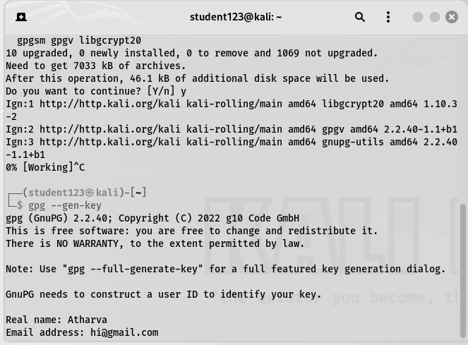

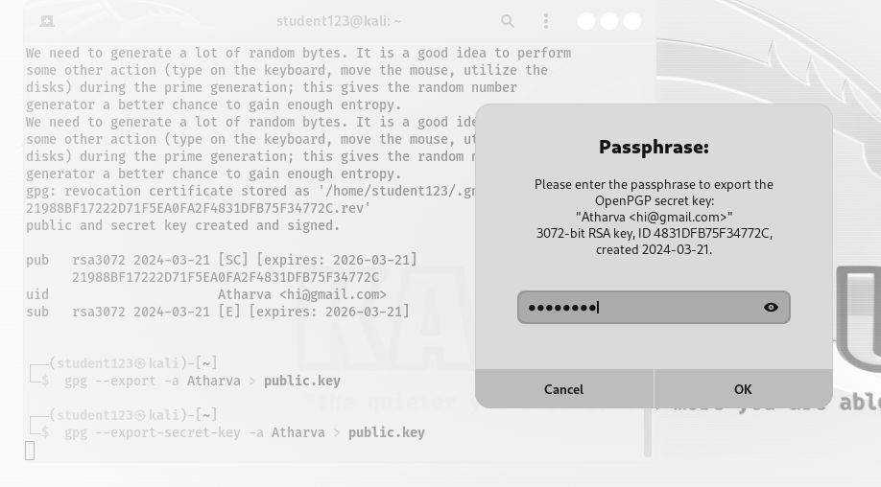


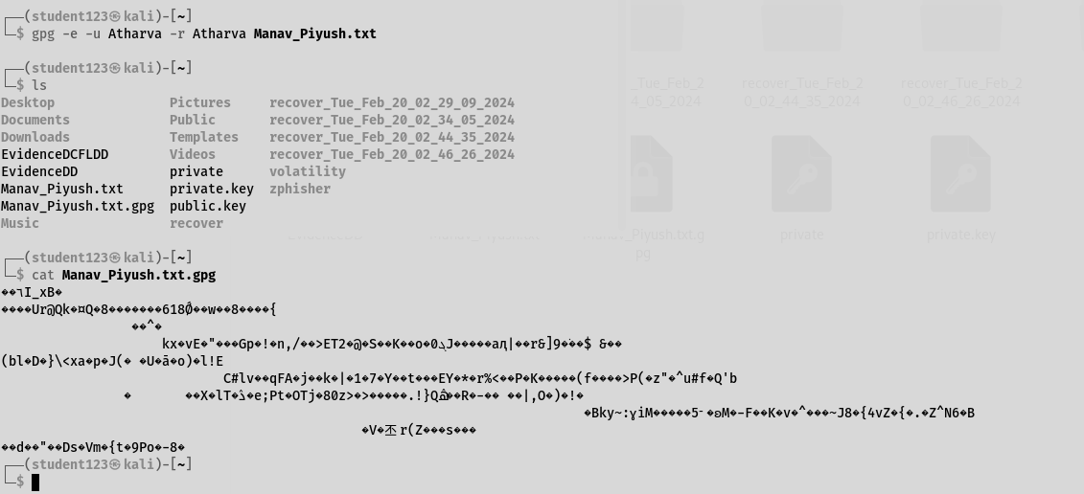

SQL Injection:

1. Install and upgrade sqlmap:
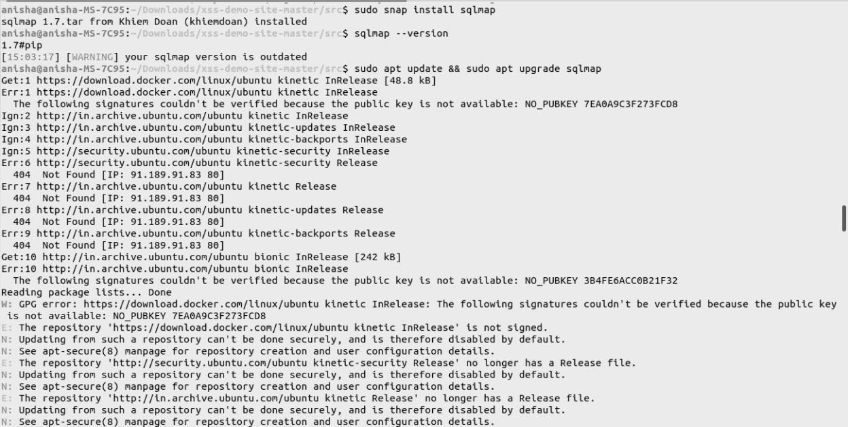
Site used for injection attack: http://testphp.vulnweb.com/listproducts.php?cat=*

2. List the databases for that site: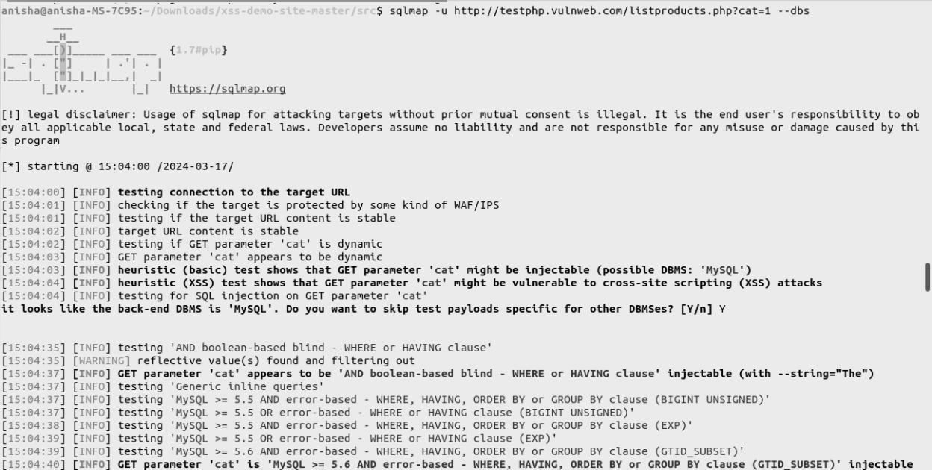
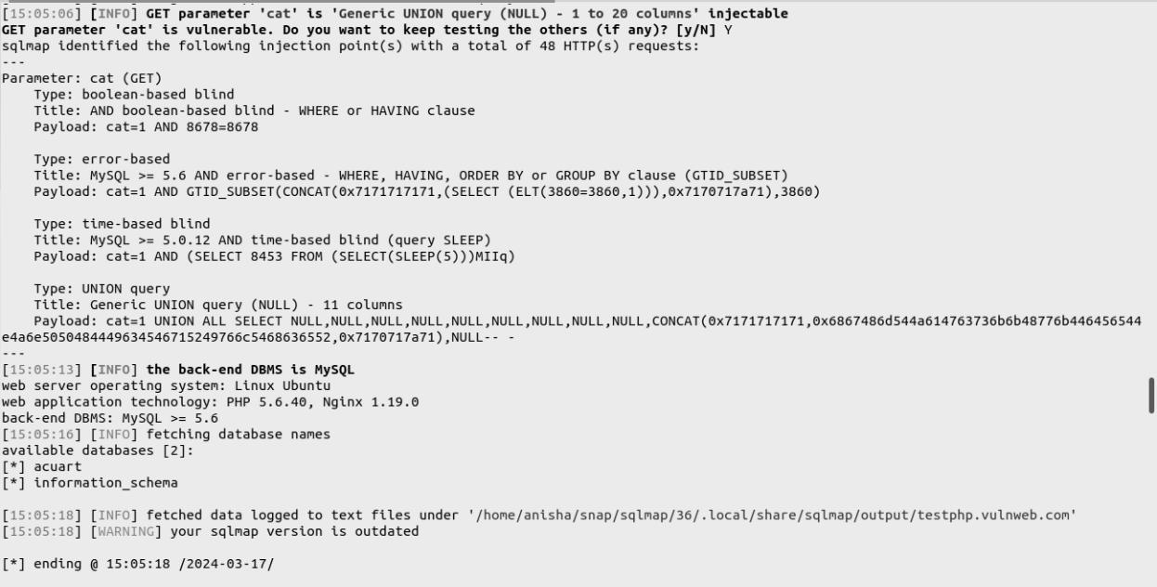

3. List the tables present in the SQL database “acuart”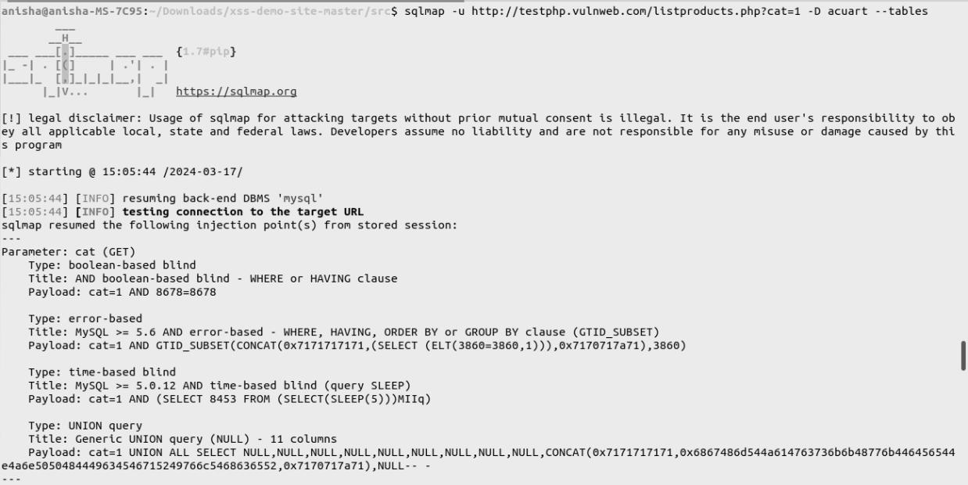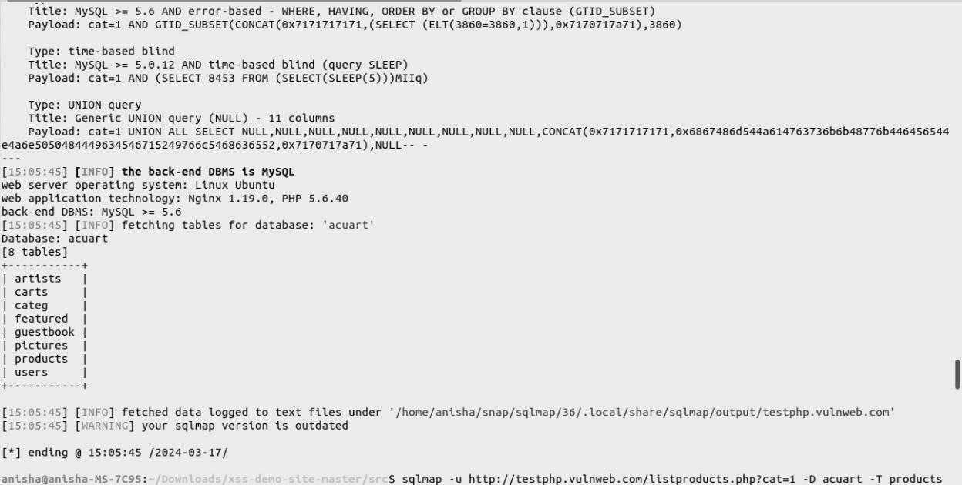
4. List the different columns of the database “acuart”, table “products”:
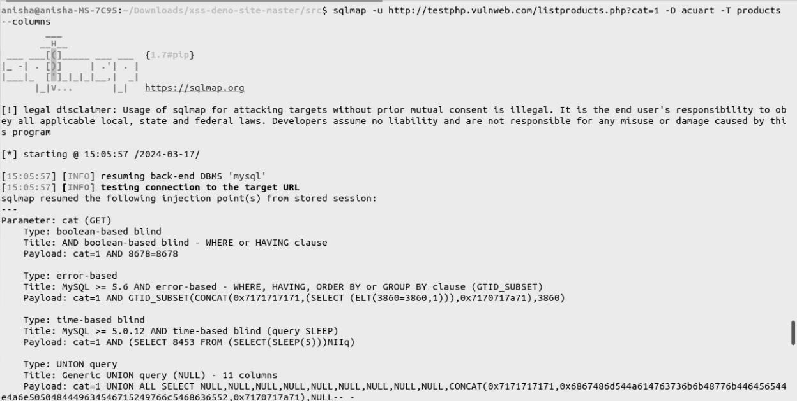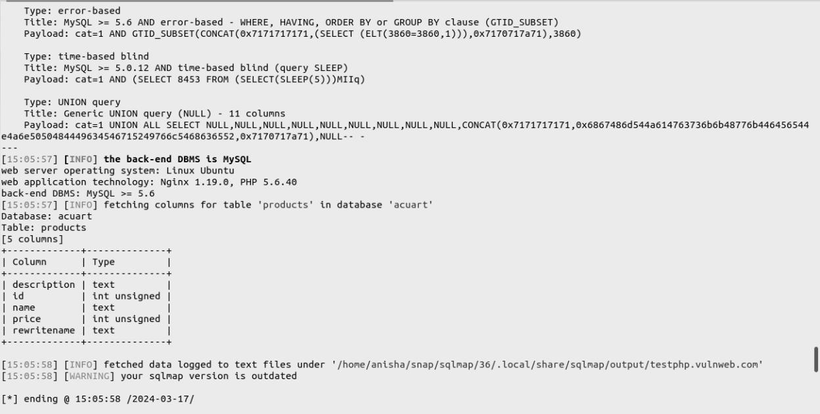
5. List the items stored in the products table of acuart database:
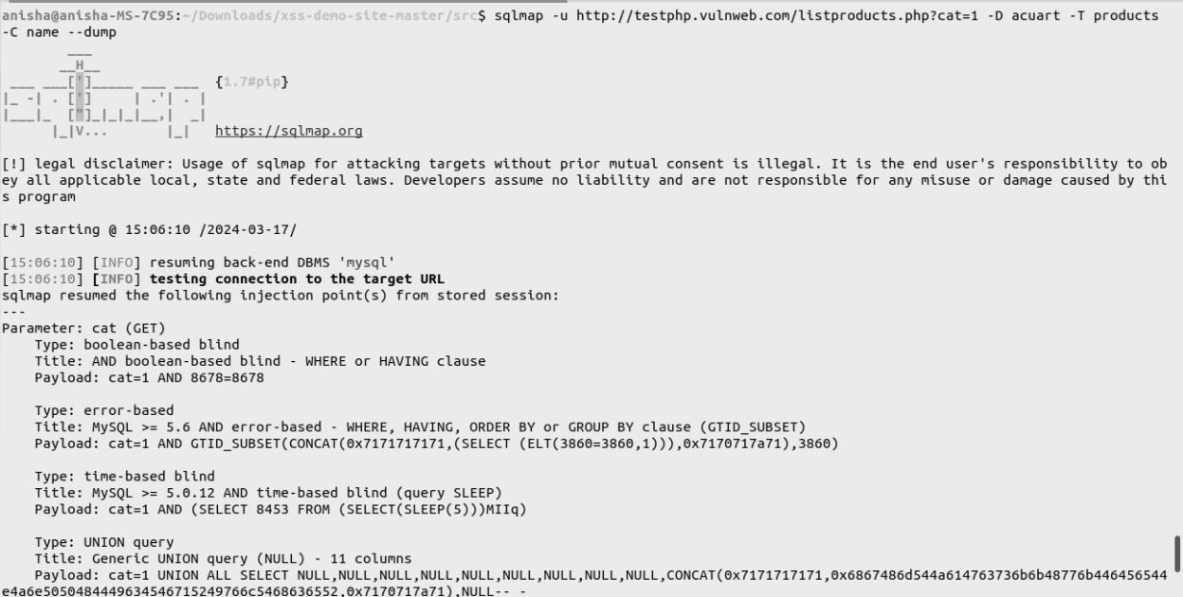
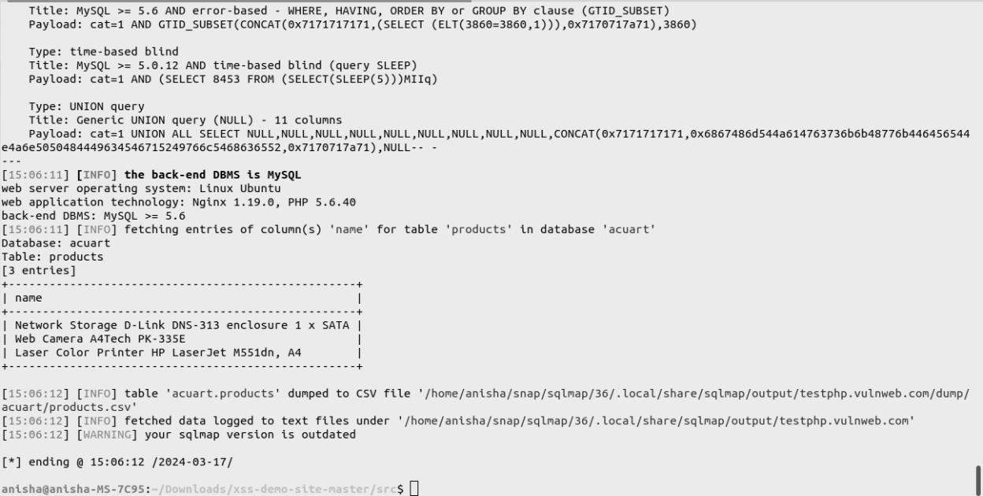

Cross site scripting:

1. Visit the site for the xss simulation:
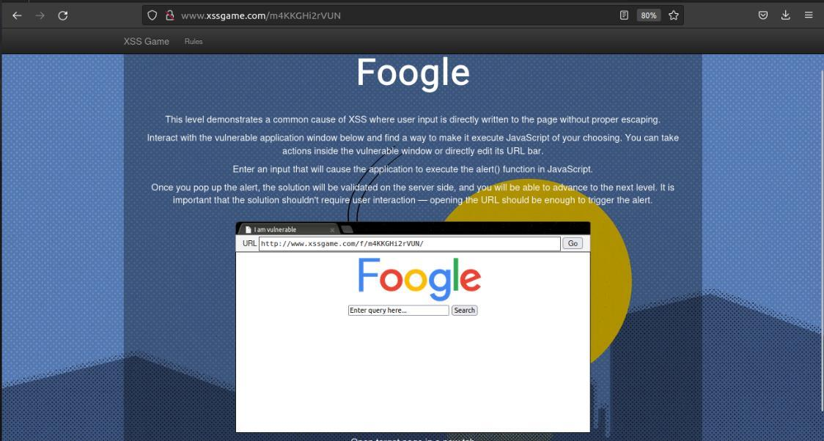
2. Enter a input which evokes the js alert() function:
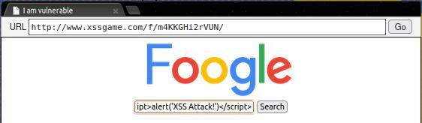
3. A popup successfully displays the message in alert() function.
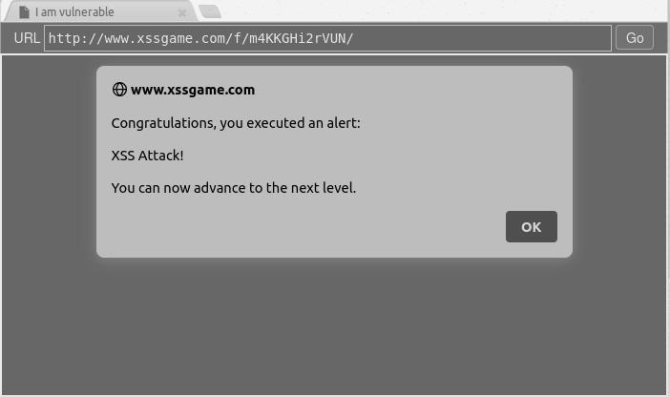

Conclusion: In conclusion, both SQL Injection and Cross-Site Scripting (XSS) represent critical vulnerabilities in web applications, posing significant risks to data security and user privacy. Understanding the intricacies of these attacks, including their attack vectors, exploitation techniques, and mitigation strategies, is paramount for developing robust defense mechanisms. Practical simulations further underscore the real-world impact of these vulnerabilities, emphasizing the importance of diligent input validation, output encoding, and security awareness among developers and organizations. By implementing proactive measures such as parameterized queries, strict input validation, Content Security Policy (CSP), and regular security updates, organizations can effectively mitigate the risks posed by SQL Injection and XSS, safeguarding their web applications and sensitive data against exploitation.

